1. Install the ALM Connectivity.

ALM Default page -> Tools -> HP ALM Connectivity

1. Create an excel file specifying the users you want to move to Viewer role.

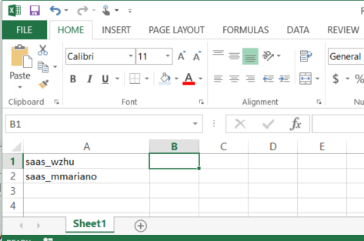

1. Launch the tool and enter the server url. Click on Initialize Server.
2. Authenticate by entering the user name and password. The user running the tool should be a TDAdmin or belong to a group with permission with user management. Click on Authenticate.
3. Select the domain and project.
4. Select “Move Users to Viewer” from the task lookup list.
5. Specify the location where the tool will write log file.
6. Click on Run.
7. Specify the location where you saved the excel file in step 2.
8. Click on Start.

